SOFTWARE REQUIREMENTS SPECIFICATION

**For**

**Blog Platform**

**Prepared by: -**

*Revanth R, Navaneetha Krishnan A, Pranesh S*

# Introduction

## Purpose

## The aim of this document is to outline the functional and non-functional requirements for a Blogging Platform. It intends to create an environment that enables users to create, manage, and interact with blog content. The platform should support easy content creation, user interaction, and reporting functionalities.

## Document Conventions

* + - Entire document should be justified.
    - Convention for Main title

Font face: Times New Roman Font style: Bold

Font Size: 14

* + - Convention for Sub title

Font face: Times New Roman Font style: Bold

Font Size: 12

* + - Convention for body

Font face: Times New Roman Font Size: 12

## Scope of Development Project

The blogging platform embodies a comprehensive scope, weaving together an array of functionalities to empower content creators and engage audiences seamlessly. At its core, it revolutionizes content management, providing a user-centric interface that simplifies content creation, editing, and organization. With a robust search infrastructure, creators effortlessly navigate their posts, categorizing content and optimizing discoverability through tags and keywords. Whether a novice or seasoned blogger, the platform champions accessibility and ease, enabling a fluid and intuitive writing experience. Responsive design ensures users can craft and manage content across devices, ensuring a seamless experience regardless of the chosen device or browser.

Beyond content, the platform fosters a vibrant community. It thrives on user engagement, facilitating interactions through comments, shares, and discussions. By prioritizing community involvement, the platform nurtures a space where users connect, exchange ideas, and engage with shared content. Administrators wield powerful tools to manage settings and user permissions, ensuring a secure environment for creators and readers alike. This focus on community engagement creates a dynamic ecosystem where users feel not just part of a platform but an active and engaged community, fostering a sense of belonging and interaction beyond conventional content consumption.

## Definitions, Acronyms and Abbreviations

JAVA -> platform independence SQL-> Structured query Language ER-> Entity Relationship

UML -> Unified Modeling Language

IDE-> Integrated Development Environment SRS-> Software Requirement Specification

## References

* + - Books

 Software Requirements and Specifications: A Lexicon of Practice, Principles and Prejudices (ACM Press) by Michael Jackson

Software Requirements (Microsoft) Second EditionBy Karl E. Wiegers

Software Engineering: A Practitioner’s Approach Fifth Edition By Roger S. Pressman

* + - Websites

**https://www.blogger.com/**

**https://firstsiteguide.com/best-blogging-platforms/**

# Overall Descriptions

## Product Perspective

Use Case Diagram of Blog Platform

*searches*

1

1 *requests*

1

1

1..*

*

search_book



1..*

check_limit

check_availability

User 1

issue_book

*request_renew*

<<include>>

*monitors_request*

1

*monitors_renew* 1

1

*performs*

*give_book*

<<include>>

0..*

1..*

renew_book

verify_member

<<include>>

*take_book*

1

1 Librarian

Student

0..*

1..*

*adds_new_book*

*perform_transaction_updation*

Staff

*

*

return_book

View_logs

<<extend>>

add_book

*

calculate_fine

update_record

The Blogging Platform is represented via a Use Case Diagram illustrating user interactions. Users, both authors and readers, can interact with the system to create, manage, and view blog content. The system supports functionalities for blog creation, content search, and user engagement features.

## Product Function

Entity Relationship Diagram of Blog platform

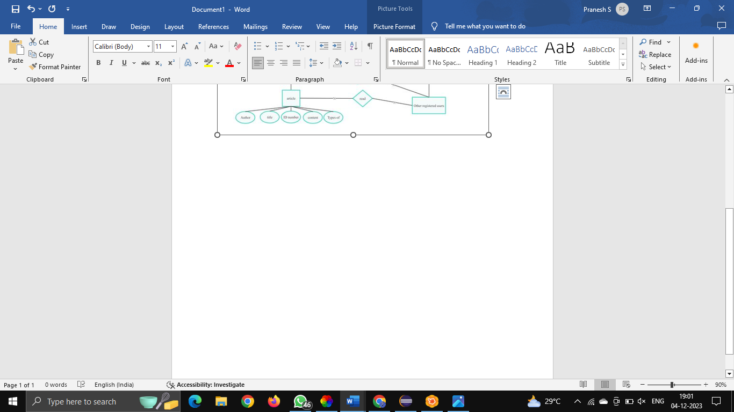

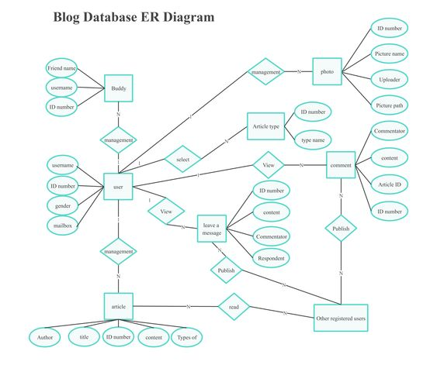

The platform offers an Entity Relationship Diagram showcasing real-time blog information. It aims to streamline blog management, user interaction, and reporting features. Authors and readers interact with the platform, with the former having administrative privileges for content management. Blogs can act as a funnel that plays an important role in conversion. But to have a perfect blog, you need to focus on some important aspects that can make your content more impressive and creative, creating a legit platform. The prime concern of a blog is usually to have as many visitors as possible. This is not so easy to create such flow through blogs as it’s a challenge. Besides having quality content, a few things add value to a blog site. Though your blog is full of rich content, it’s not always possible to grab visitors’ attention if not presented in a proper way. Hence, the subject of appearance is correlated with your blog’s looks and functionalities, which can ultimately turn your visitors into productive clients.

## User Classes and Characteristics

The system caters to different user classes, including authors (administrators) and readers. Authors have administrative privileges, enabling them to create, manage, and oversee blog content. Readers can view blogs, search for content, and engage through comments and interaction. Advantages of Blog Platform are as follows;

* + - Increase brand awareness
    - Boost our website SOE
    - Reach new potential customers and clients
    - Stand apart from your competition
    - Develop trust among the customers
    - Create content for other platforms
    - Grow your email list

The features that are available to the Blog platforms are: -

* + - Contemporary Design Pattern
    - Dynamic Presentation
    - Social Media Involvement
    - Structural Design
    - Numerous Posting Formats

## Operating Environment

The product will be operating in windows environment. The Blog platform is a website and shall operate in all famous browsers, for a model we are taking Microsoft Internet Explorer, Google Chrome, and Mozilla Firefox. Also, it will be compatible with the IE 6.0. Most of the features will be compatible with the Mozilla Firefox & Opera 7.0 or higher version. The only requirement to use this online with internet connection.

The hardware configuration includes Hard Disk: 40 GB, Monitor: 15” Color monitor, Keyboard: 122 keys. The basic input devices required are keyboard, mouse and output devices are monitor, printer etc.

## Assumptions and Dependencies

The assumptions are:-

* + - The coding should be error free
    - The system should be user-friendly so that it is easy to use for the users
    - The information of all users must be stored in a database that is accessible by the website
    - The system should have more storage capacity and provide fast access to the database
    - The system should provide search facility and support quick transactions
    - The Blog platform is running 24 hours a day
    - Users may access from any computer that has Internet browsing capabilities and an

Internet connection

* + - Users must have their correct usernames and passwords to enter into their online accounts and do actions

The dependencies are:-

* + - The specific hardware and software due to which the product will be run
    - On the basis of listing requirements and specification the project will be developed and run
    - The end users (admin) should have proper understanding of the product
    - The system should have the general report stored
    - The information of all the users must be stored in a database that is accessible by the Blog platform

## Requirement

Software Configuration: -

This software package is developed using java as front end which is supported by sun micro system. Microsoft SQL Server as the back end to store the database.

Operating System: Windows NT, windows 98, Windows XP Language: Java Runtime Environment, Net beans 7.0.1 (front end) Database: MS SQL Server (back end)

Hardware Configuration: -

Processor: Pentium(R)Dual-core CPU Hard Disk: 40GB

RAM: 256 MB or more

## Data Requirement

The inputs consist of the query to the database and the output consists of the solutions for the query. The technical requirements for blogging software are much more specific than what you'd need for a typical Web site. Most blog software use a mix of several kinds of Web server technology that are ideal for running dynamic Web sites like blogs.

# External Interface Requirement

## GUI

The software provides good graphical interface for the user and the administrator can operate on the system, performing the required task such as create, update, viewing, editing the posts.

* + - A central hub where users can manage their blog posts, settings, media, and other relevant aspects of their blog.
    - An easy-to-use editor with formatting options (such as bold, italics, headings, etc.), media embedding, and maybe even a preview mode to see how the post will look before publishing.
    - The user interface must be customizable by the administrator
    - All the modules provided with the software must fit into this graphical user interface and accomplish to the standard defined
    - The design should be simple and all the different interfaces should follow a standard

template

* + - The user interface should be able to interact with the user management module and a part of the interface must be dedicated to the login/logout module

Login Interface:-

In case the user is not yet registered, he can enter the details and register to create his account. Once his account is created he can ‘Login’ which asks the user to type his username and password. If the user entered either his username or password incorrectly then an error message appears.

Search:-

The user can enter user id and search for the posts made by him. Each user have different user id which makes user to get the exact person they are searching for.

Categories View:-

Categories view shows the categories of posts available and provides ability to the administrator to add/edit or delete category from the list of posts.

Administrators Control Panel:-

This control panel will allow administrator to add/remove users; add, edit, or remove a post And manage editing options.

# System Features

The users of the system should be provided the surety that their account is secure. This is possible by providing:-

* User authentication and validation of members using their unique member ID
* Admin, editor, contributor, and subscriber roles with varying levels of access and permissions.
* Allow users to create and manage their profiles with bio, social links, and preferences. Only administrator will see and manage all member accounts.
* An intuitive editor to create, edit, and format blog posts with text, images, videos, etc.
* Capability to save drafts and schedule posts for future publishing.
* Organization of posts into categories and tags for better navigation and SEO.

# Other Non-functional Requirements

## Performance Requirement

The proposed system that we are going to develop will be used as the Chief performance system within the different campuses of the university which interacts with the university staff and students. Therefore, it is expected that the database would perform functionally all the requirements that are specified by the university.

* + - The performance of the system should be fast and accurate
    - Blog platform shall handle expected and non-expected errors in ways that prevent loss in information and long downtime period. Thus, it should have inbuilt error testing to identify invalid username/password
    - The system should be able to handle large amount of data. Thus, it should accommodate high number of books and users without any fault

## Safety requirement

The database may get crashed at any certain time due to virus or operating system failure. Therefore, it is required to take the database backup so that the database is not lost. Proper UPS/inverter facility should be there in case of power supply failure.

## Security Requirement

* + - System will use secured database
    - Normal users can just read information but they cannot edit or modify anything except their personal and some other information.
    - System will have different types of users and every user has access constraints
    - Proper user authentication should be provided
    - No one should be able to hack users’ password
    - There should be separate accounts for admin and members such that no member can access the database and only admin has the rights to update the database.

## Requirement attributes

* + - There may be multiple admins creating the project, all of them will have the right to create changes to the system. But the members or other users cannot do changes
    - The project should be open source
    - The Quality of the database is maintained in such a way so that it can be very user friendly to all the users of the database
    - The user be able to easily download and install the system

## Business Rules

A business rule is anything that captures and implements business policies and practices. A rule can enforce business policy, make a decision, or infer new data from existing data. This includes the rules and regulations that the System users should abide by. This includes the cost of the project and the discount offers provided. The users should avoid illegal rules and protocols. Neither admin nor member should cross the rules and regulations.

## User Requirement

The users of the system are members who act as administrator to maintain the system. The members are assumed to have basic knowledge of the computers and internet browsing. The administrators of the system should have more knowledge of the internals of the system and is able to rectify the small problems that may arise due to disk crashes, power failures and other catastrophes to maintain the system. The proper user interface, user manual, online help and the guide to install and maintain the system must be sufficient to educate the users on how to use the system without any problems.

The admin provides certain facilities to the users in the form of:-

* + - Backup and Recovery
    - Forgot Password
    - Data migration i.e. whenever user registers for the first time then the data is stored in the server
    - Data replication i.e. if the data is lost in one branch, it is still stored with the server
    - Auto Recovery i.e. frequently auto saving the information
    - Maintaining files i.e. File Organization
    - The server must be maintained regularly and it has to be updated from time to time

# Other Requirements

## Data and Category Requirement

The blog platform necessitates a structured framework for data management, encompassing user, content, comment, and analytics data. User data profiles including usernames, emails, encrypted passwords, and social links, categorized into distinct roles (admins, editors, contributors, subscribers) with specific access levels, are integral. Content data, comprising blog posts with titles, authors, publication dates, along with associated categories, tags, and media files, necessitates structured organization. Additionally, comment data, delineating text, authors, dates, and moderation statuses, is pivotal for fostering engagement. Analytics data encompassing traffic metrics, user engagement, and demographic details further enhances insights. For efficient content organization, hierarchical post categories, non-hierarchical tags, and moderation flags are imperative, offering a taxonomy for seamless navigation and filtering. These categories extend to user profiles and moderation statuses, ensuring a well-organized and user-centric experience while facilitating robust content management and analysis.

## Appendix

A: - Admin- Abbreviation- Acronym- Assumptions: - Books- Business rules: - Class- Client- Conventions; D: - Data requirement- Dependencies: - GUI; K: - Key; N: - Non-functional Requirement; O: Operating environment; P: - Performance- Perspective- Purpose; R: - Requirement- Requirement attributes; S: - Safety- Scope- Security-System features; U: - User- User class and characteristics- User requirement.This format organizes the terms alphabetically and groups them under the respective letters as per your specified structure.

## Glossary

The following are the list of conventions and acronyms used in this document and the project as well:

* + - Administrator: A login id representing a user with user administration privileges to the software
    - User: A general login id assigned to most users
    - Client: Intended users for the software
    - SQL: Structured Query Language; used to retrieve information from a database
    - SQL Server: A server used to store data in an organized format
    - Layer: Represents a section of the project
    - User Interface Layer: The section of the assignment referring to what the user interacts with directly
    - Application Logic Layer: The section of the assignment referring to the Web Server. This is where all computations are completed
    - Data Storage Layer: The section of the assignment referring to where all data is recorded
    - Use Case: A broad level diagram of the project showing a basic overview
    - Class diagram: It is a type of static structure diagram that describes the structure of a system by showing the system’s cases, their attributes, and the relationships between the classes
    - Interface: Something used to communicate across different mediums
    - Unique Key: Used to differentiate entries in a database

## Class Diagram

The blog platform's class diagram encapsulates several essential classes interconnected to facilitate its functionality. At its core are the User classes, distinguishing between standard Users and elevated Admins with distinct privileges. These classes hold attributes like UserID, Username, Email, and Password, while the Admin class inherits additional managerial capabilities. Central to content management, the Post class orchestrates blogs, storing PostID, Title, Content, and association with authors via UserID, categorized under Category and tagged with Tag attributes. Enabling interaction, the platform integrates Comment and Like/Dislike classes, facilitating user engagement with PostID and UserID links. Supporting media incorporation, the Media class relates filenames and types to respective PostIDs. Analytics tracking is represented by an Analytics class, capturing metrics associated with PostIDs, such as Views, Likes, Shares, and Comments. Security functionalities are encapsulated within the Security class, encompassing authentication, encryption, and access control, while the GUI class manages user-system interactions. These classes and their relationships establish the core structure of the blog platform, fostering user engagement, content management, and system security.

